**WEB TECHNOLOGY**

# Minor Assignment-1

**Name- Aniket Chatterjee**

**Roll no- 2005783**

**Section- CSE26**

**DATE-17/01/2022**

HTML CODE

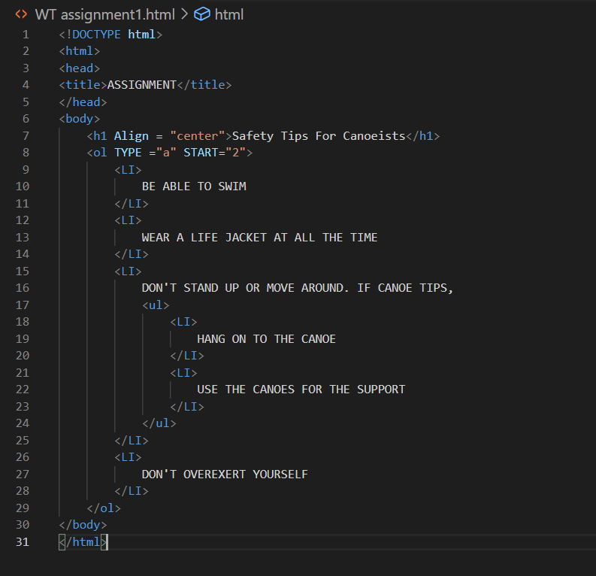

**OUTPUT--**

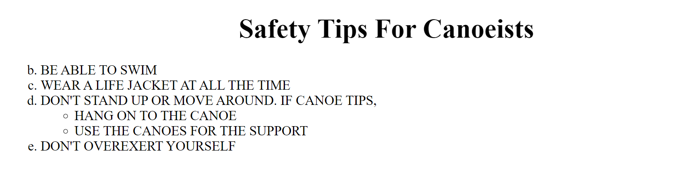

**-2005783**